# Material R32a [1] [2] [3] Saturation Temperature: 221.5k

|  |  |  |  |
| --- | --- | --- | --- |
| Property | R134-a Liquid | R134-a Vapor | Unit |
| Density | 1240 | 13.6 |  |
| Dynamic Viscosity | 0.00031 | 1.1e-5 | kg/ (m s) |
| Molecular weight | 52.02389 | 52.02389 |  |
| Specific heat | 1900 | Piecewise-polynomial |  |
| Standard state enthalpy | -4.265e+08 | -1.932e+08 |  |
| Thermal conductivity | 0.105 | 0.0105 |  |

## E = 0.8

### Geometry

Major Axis a = 11.90625 mm

Minor Axis b = 9.525 mm



### Temperature

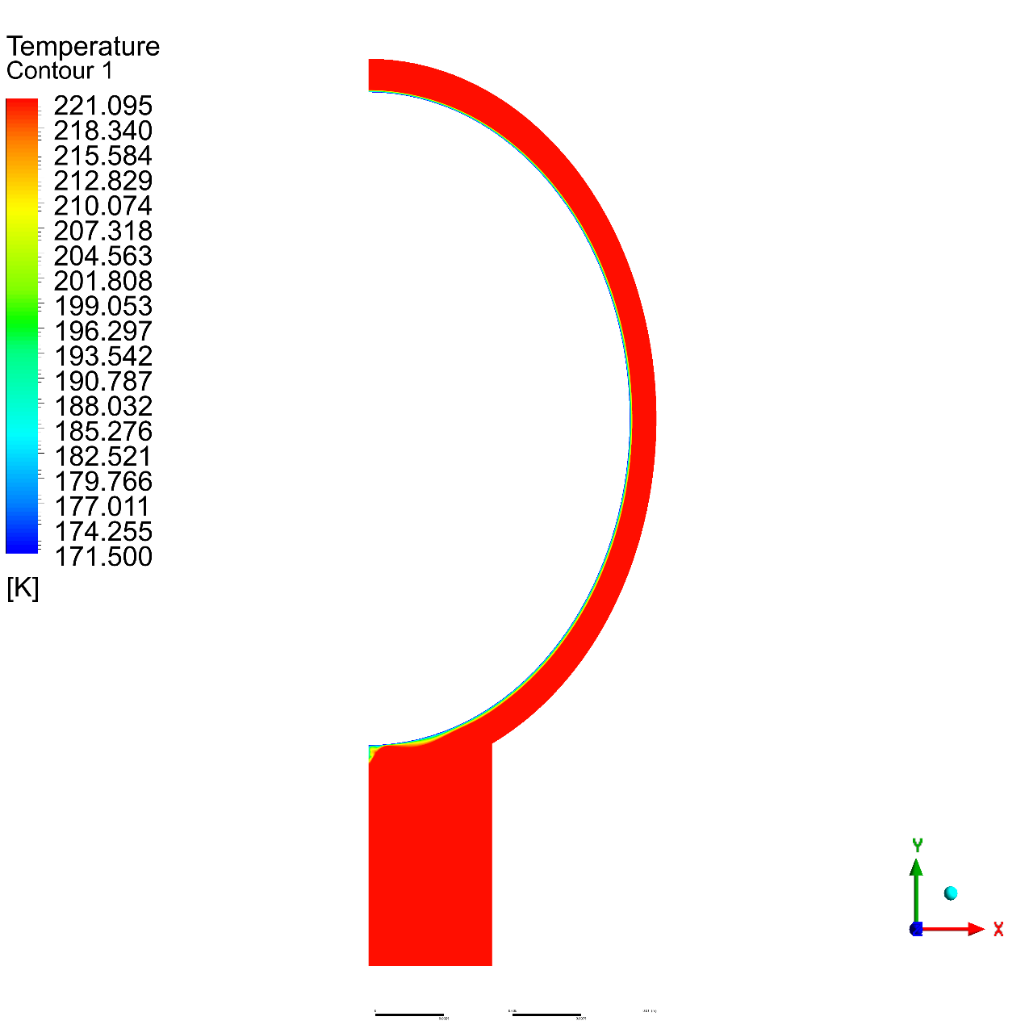

### Volume Fraction

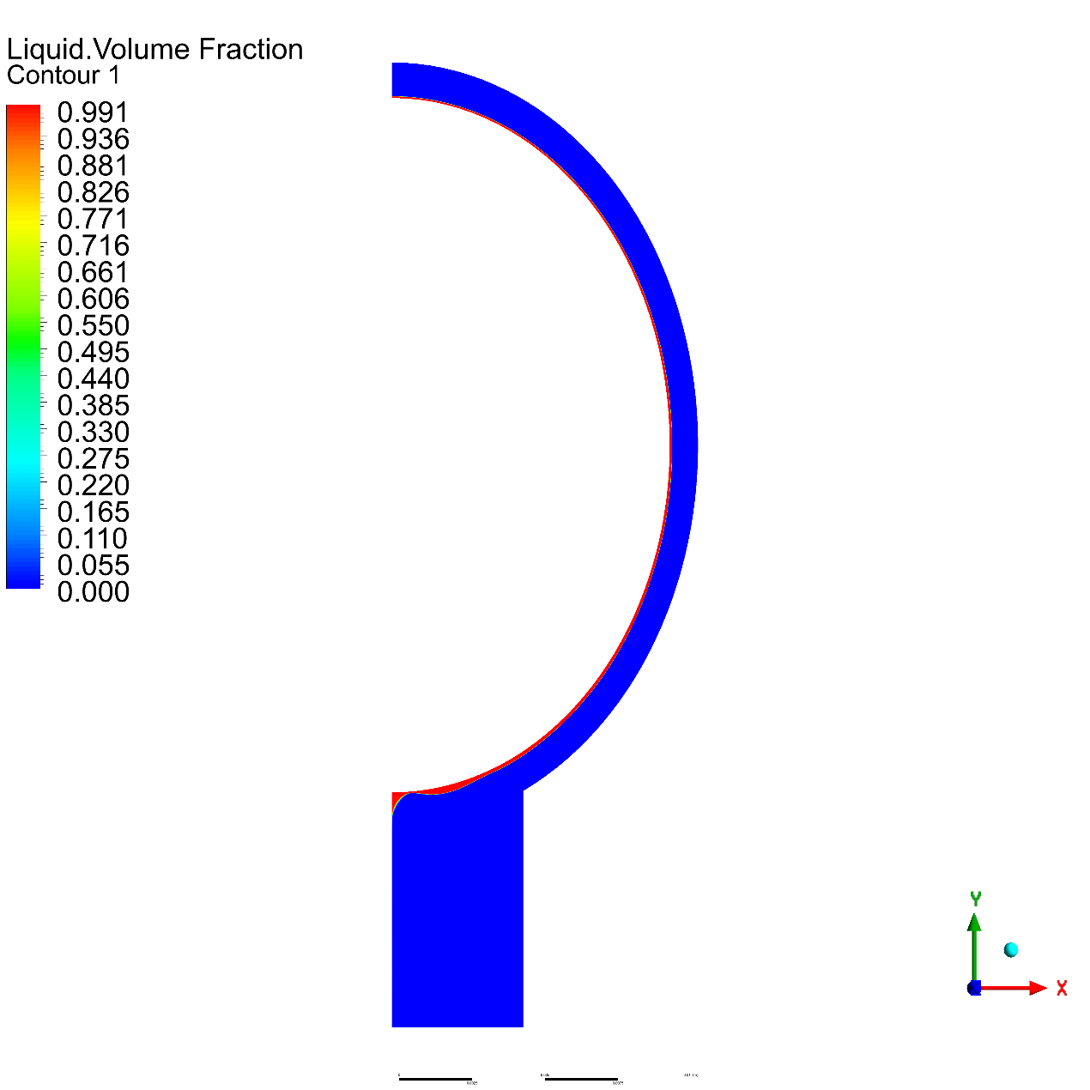

## E = 0.6

### Geometry

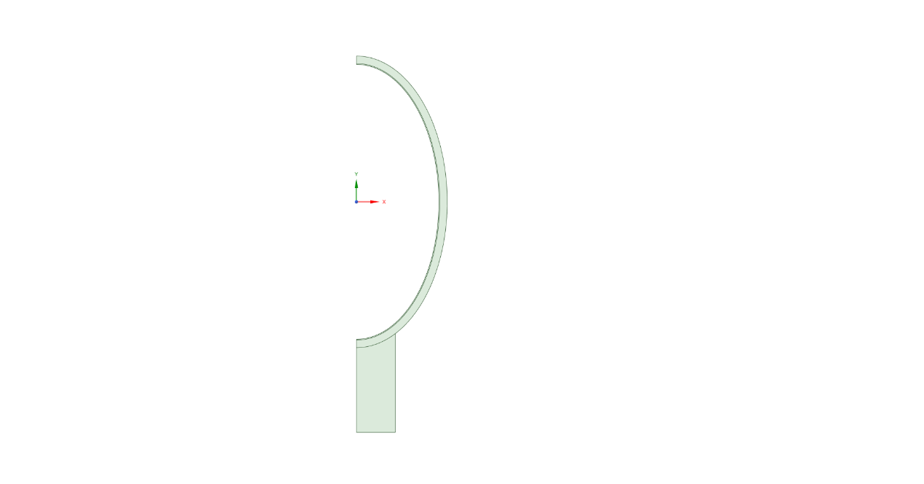

Major Axis a = 15.857 mm

Minor Axis b = 9.525 mm

### Temperature

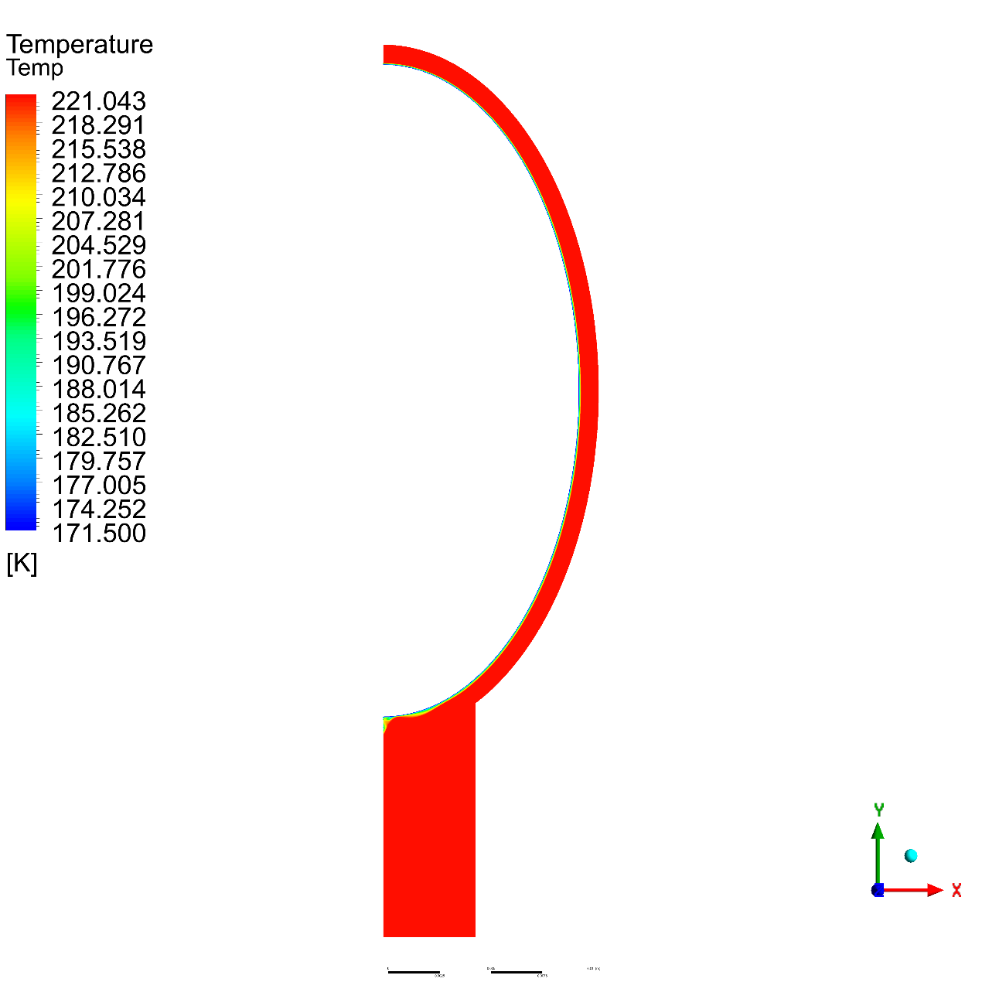

### Volume Fraction

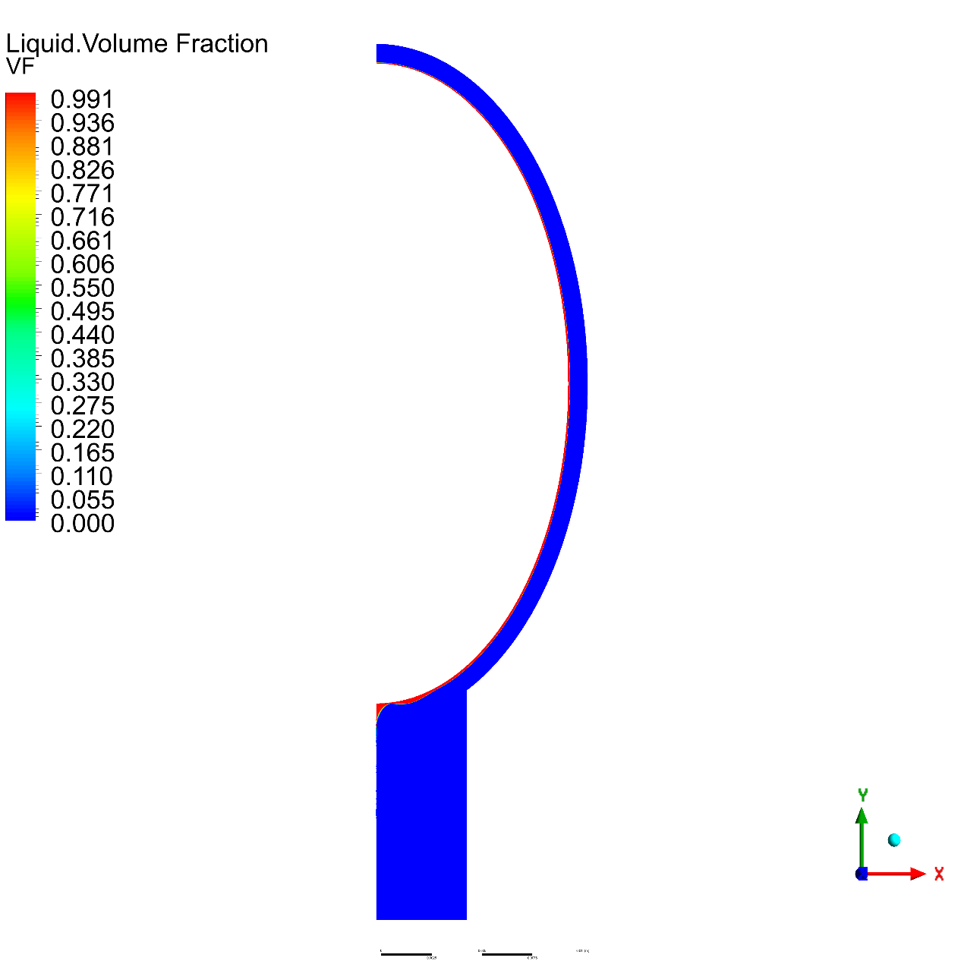

## E = 0.4

### Geometry

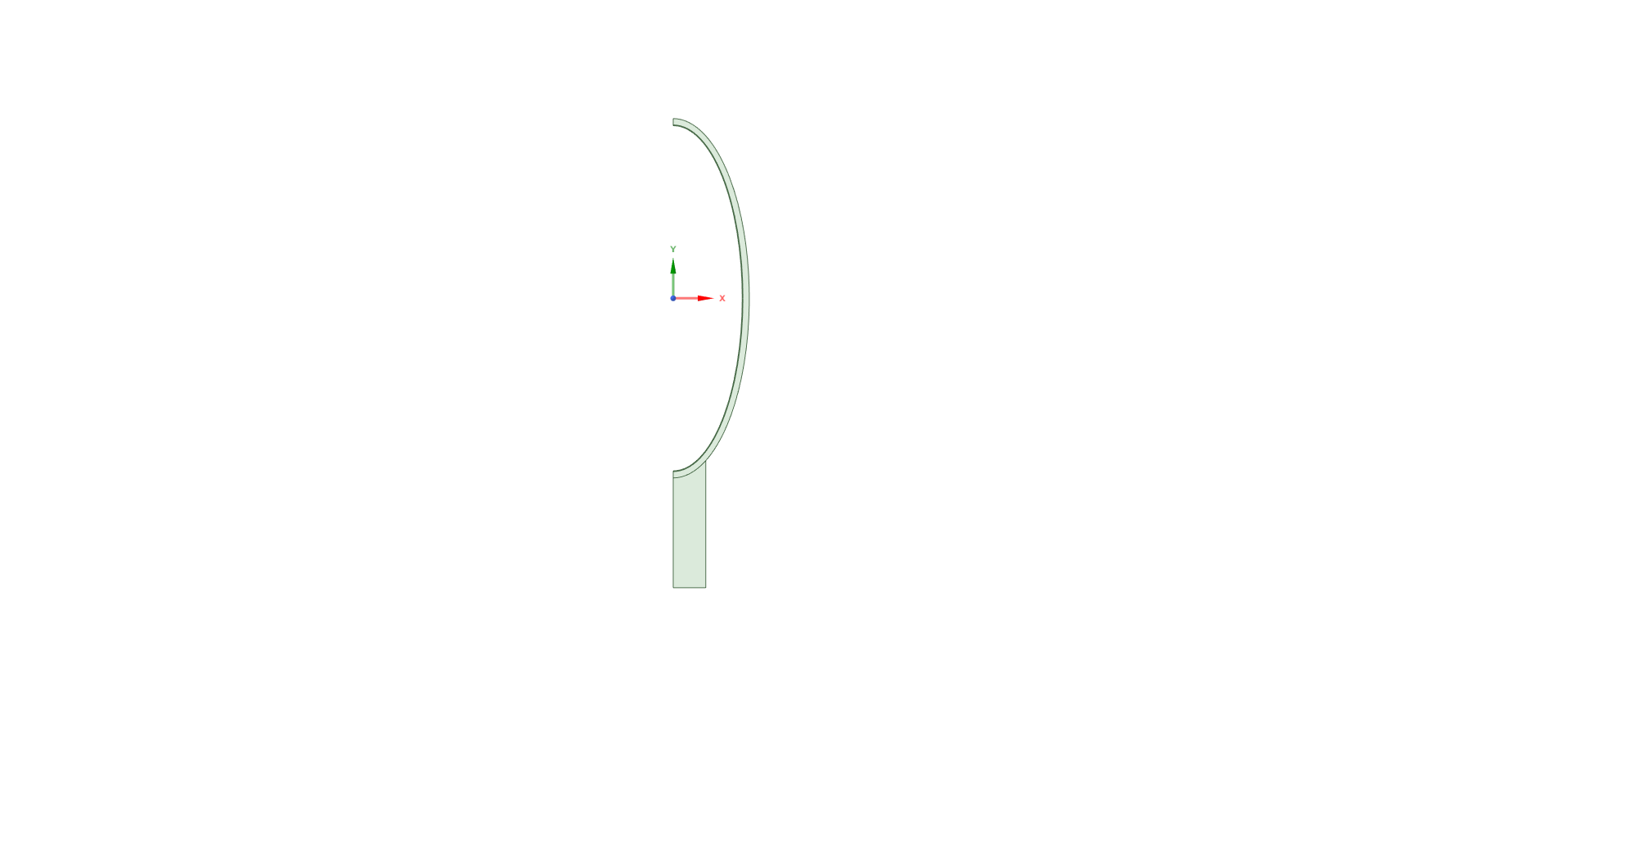

Major Axis a = 23.8125 mm

Minor Axis b = 9.525 mm

### Temperature

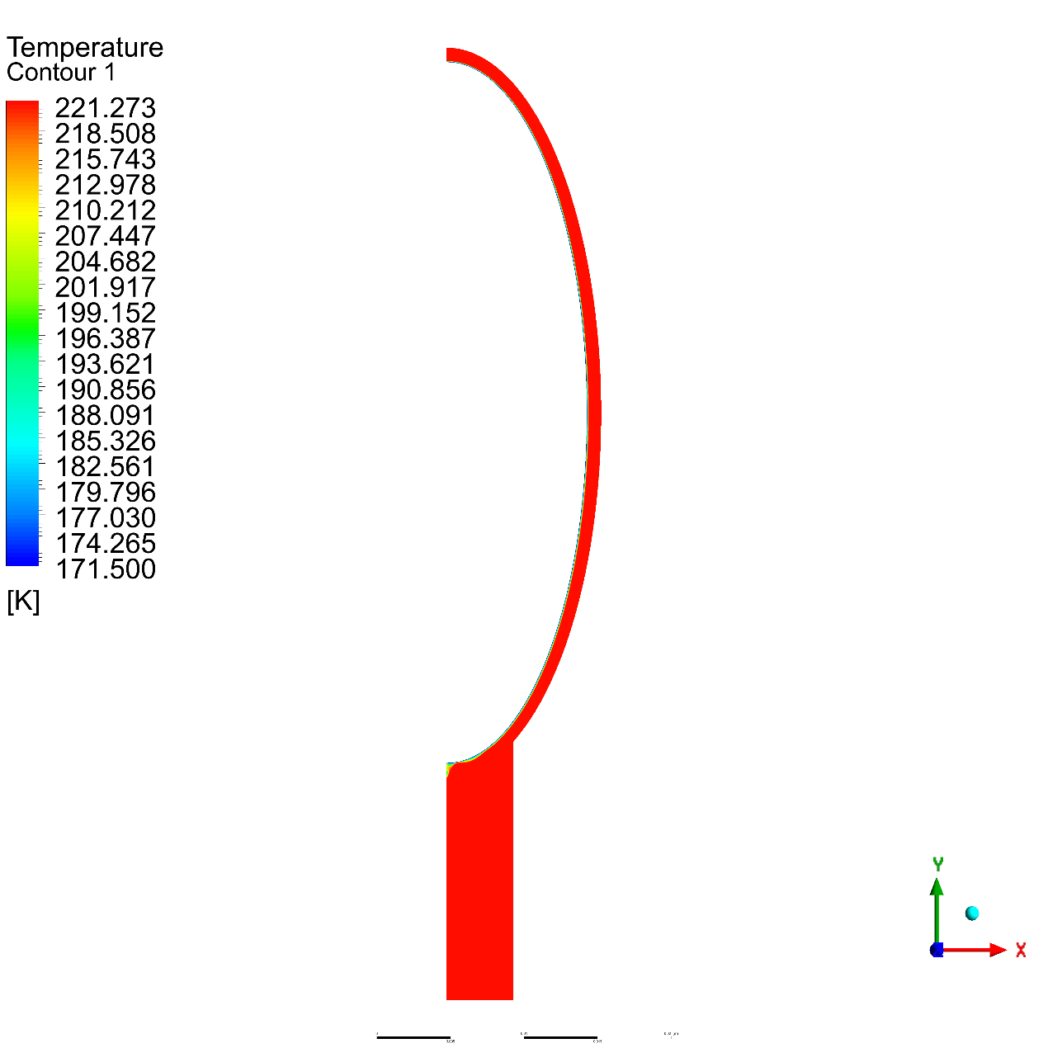

### Volume Fraction

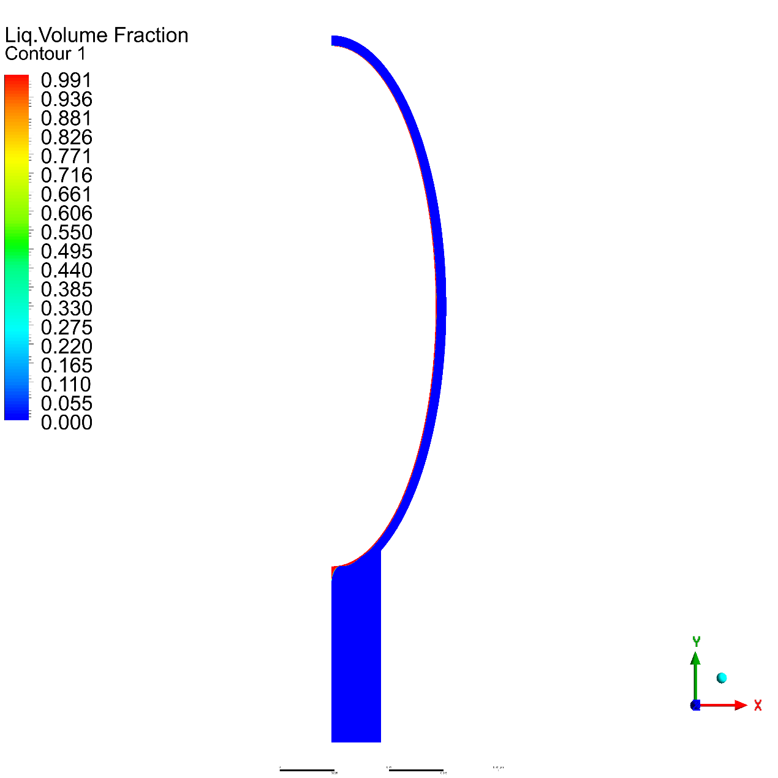

## E = 0.2

### Geometry

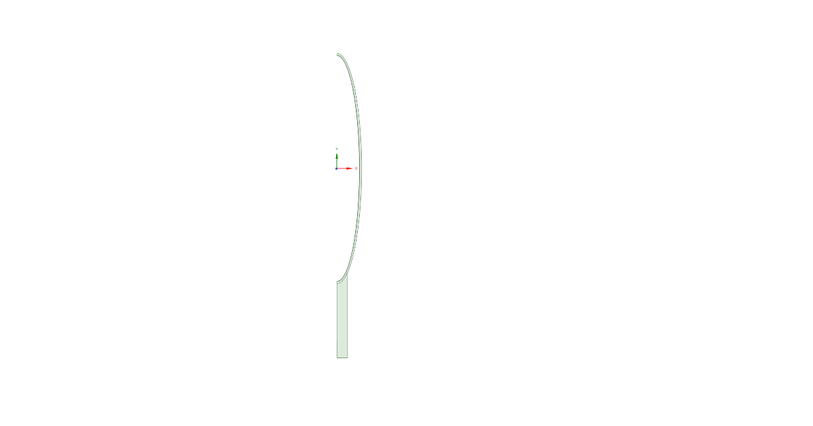

Major Axis a = 47.625 mm

Minor Axis b = 9.525 mm

### Temperature

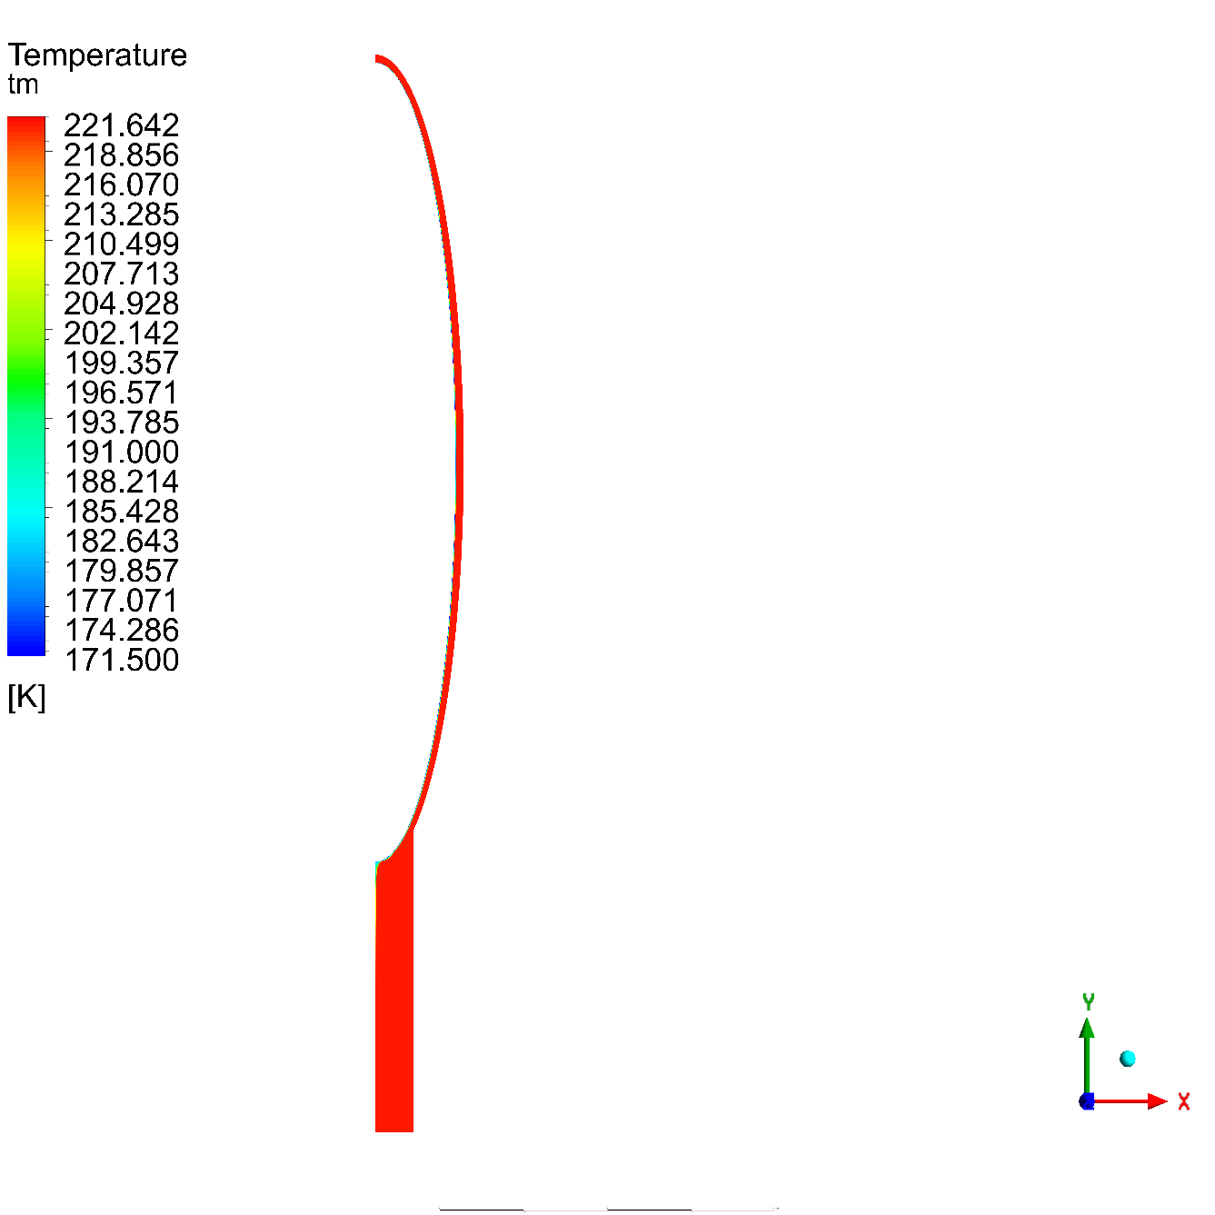

### Volume Fraction

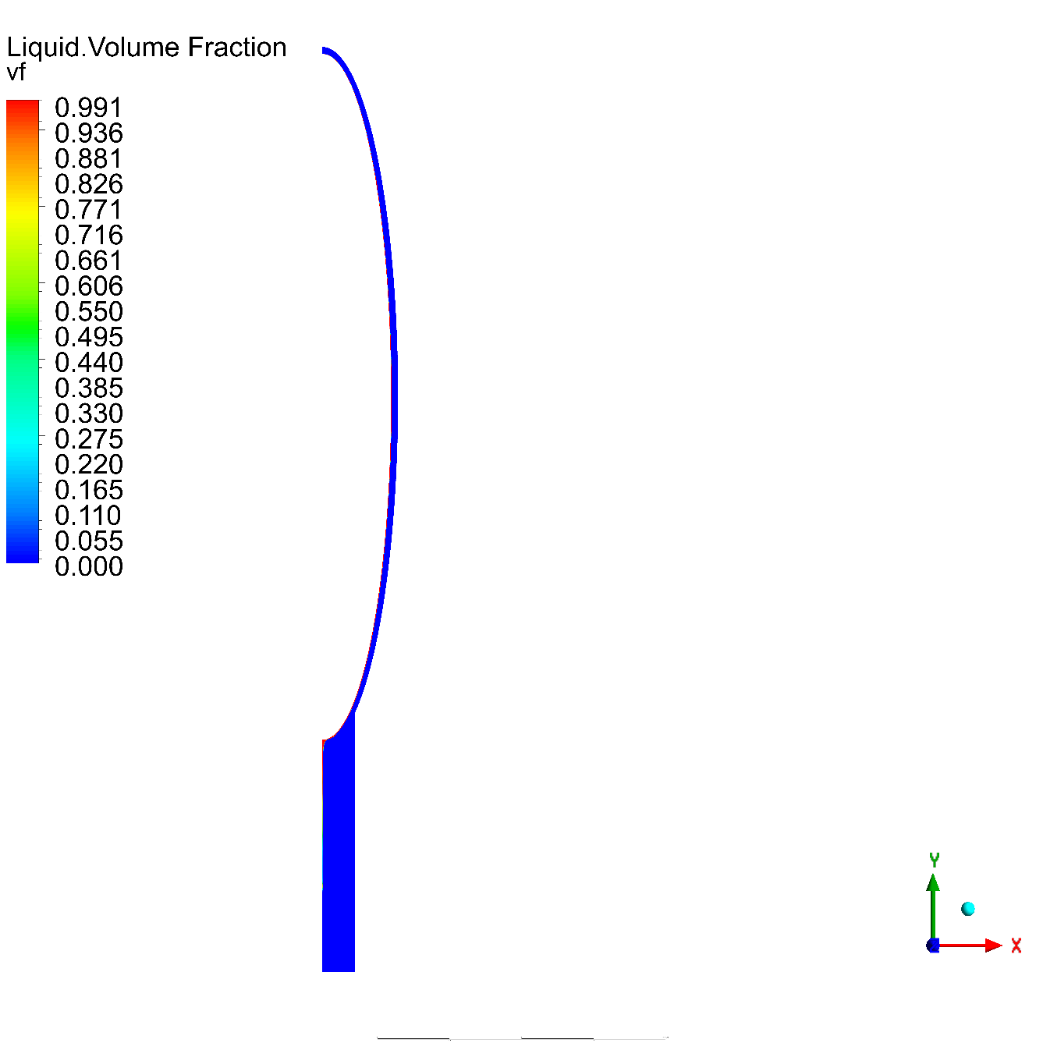

## Phase Fraction Charts



## Temperature Charts



Wall Heat Flux



# References

|  |  |
| --- | --- |
| [1] | E. ToolBox. [Online]. Available: <https://www.engineeringtoolbox.com/refrigerants-d_902.html> |
| [2] | mitsubishielectricmalaysia. [Online]. Available: <https://www.mitsubishielectricmalaysia.com/wp-content/uploads/2022/09/R32-Booklet_ENG.pdf> |
| [3] | J. &. C. B. &. Z. Z. &. L. D. Tian, "[Theoretical Study on Cryogen Spray Cooling in Laser Treatment of Ota’s Nevus: Comparison and Optimization of R134a, R404A and R32," 2020](https://www.researchgate.net/publication/346597075_Theoretical_Study_on_Cryogen_Spray_Cooling_in_Laser_Treatment_of_Ota's_Nevus_Comparison_and_Optimization_of_R134a_R404A_and_R32). |
| [4] | Freon™. [Online]. Available: https://www.freon.com/en/-/media/files/freon/freon-134a-push-bulletin.pdf?rev=299648e517aa4efda7674b2db8de0f3b. |
| [5] | engineeringtoolbox. [Online]. Available: https://www.engineeringtoolbox.com/r134a-properties-d_1682.html. |